Human Computer Interaction - Politecnico di Milano

Main Project - Math Dots (Kids Game)

Prof. Franca Garzotto

Group - The Foreigners

Cássio Scofield - scofieldcassio@gmail.com
Erik Hane - ehane@kth.se

Introduction

Connect dots is a very famous childrens game. It helps children to count and learn the alphabet. The game is fairly simple you need to connect adjacent dots following a defined pattern that is usually numbers or letters in the correct order. After connecting the dots a picture is formed.
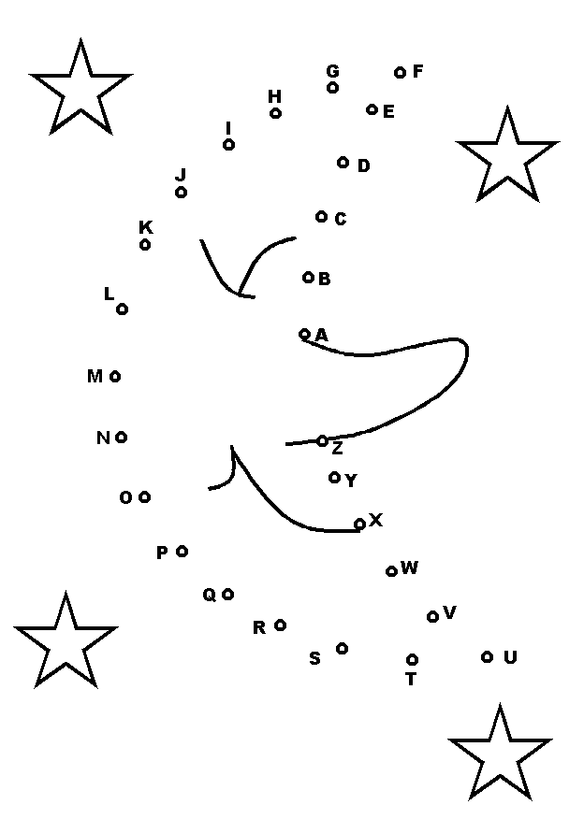  Paper Connect Dots (alphabetical order) | 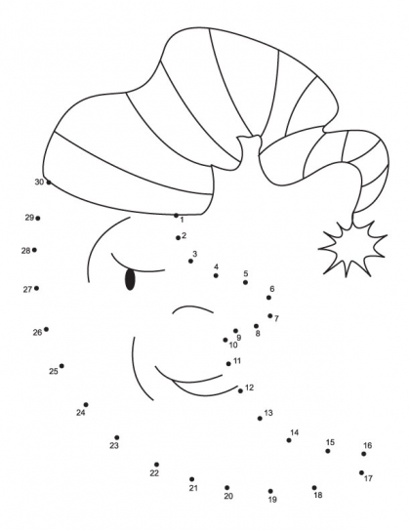  Paper Connect Dots (numerical order)

Game details: http://en.wikipedia.org/wiki/Connect_the_dots

Objective

Create a tablet/smartphone version of the connect the dots game which can not only teach counting but also simple math such as addition, subtraction, multiplication, division, etc. The game should also support multiplayer function, both cooperative and competitive mode.

Technology

We chose to use the Android operational system because we have Android devices to test it on and because the group is familiar with the Java programming language.

Interation and Gameplay

The interaction with game will be touchscreen. The player selects the dots by clicking near them and a line will be formed between between the selected dot and the previous one if the selected dot is correct. If the selected dot is not the correct one this will be indicated to the player.
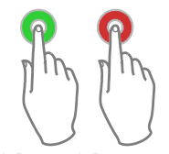
Feedback indication (Left-correct/Right-wrong)

Singleplayer

In the singleplayer mode the player gets a higher score the faster he completes the level, but gets penalized if he makes mistakes.

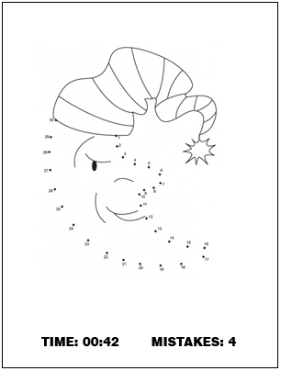

Cooperative Multiplayer

In the cooperative multiplayer mode, both players share the same screen. In the cooperative mode, to enhance teamwork, each player draws a separate part of the final picture, for exemple, player one draws a moon and player two draws a star and when the level is completed the two parts are merged in the same drawing.

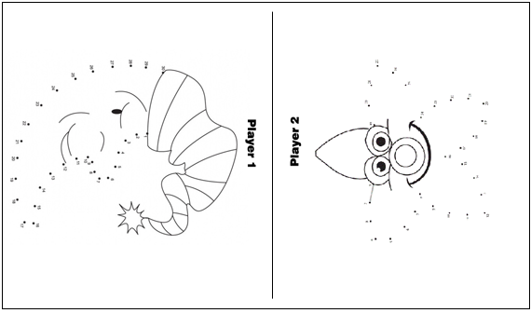

Competitive Multiplayer

In the competitive multiplayer mode, both players share the same screen but the draw the same figure, the one who completes first wins.

